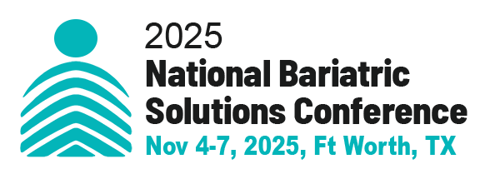

SPONSORSHIP and EXHIBIT REGISTRATION/INVOICE
PLEASE PRINT
Company Name
Address
City |  |  |  |  |  | State |  |  | Zip
Company Email Address |  |  |  |  |  |  |  |  |  |  | Website
Company Products/Services
Contact Person Information
Contact Person Name |  |  |  |  |  |  |  |  |  |  | Title
E-mail |  |  |  |  |  |  |  |  |  | Phone
SPONSORSHIP

Grand Opening Reception Sponsor $8,950 After Apr 14, 2025 $9,950
Keynote Speaker Sponsor $8,950 After Apr 14, 2025 $9,950
General Session Speaker Sponsor $6,500 After Apr 14, 2025 $7,500
Break and Breakfast Sponsor $3,950 After Apr 14, 2025 $4,950
Select - Breakfast: Day One Day Two AND/OR
Break: Day One Day Two
Attendee Bag Sponsor $4,150 After Apr 14, 2025 $4,500
Lanyard Sponsor $3,500 After Apr 14, 2025 $4,700
Breakout Session Sponsor $1,750 After Apr 14, 2025 $2,150
Conference Guidebook Ad
Full Page $500
Half Page $300

EXHIBIT BOOTH Early Bird (before Apr 14, 2025) $4,950; Apr 14 – Aug 31, 2025 $5,950;
Sep 1 – Nov 1 $7,400 No Onsite Registration will be accepted.

No. of Booth Spaces Reserved |  | $

Total Amount:

Payment Method
Pay by credit card
Credit Card (circle one) Visa MasterCard American Express Discover
Credit Card# |  | Expiration Date
Cardholder Name: |  | (3 or 4 digit security code)
Card billing address:

Or Make check payable to Celebration Institute.
Mail to: 461 N Sunnyside Avenue, Sierra Madre. CA 91024

Or Request an online payment invoice from us.

Exhibit booths and sponsorship opportunities are limited and will be assigned on a first-come, first-served basis. However, the 2025 National Bariatric Solutions Conference reserves the exclusive right to assign exhibit space and allocate it based on any other criteria it deems appropriate for the event.

2025 National Bariatric Solutions Conference may also reconfigure the floor plan of the Exhibit Hall and reassign any exhibiting company at its sole discretion. If all exhibit space is sold out, any additional registrations received will be placed on a waiting list in the order in which they are received.

Cancellation:
Exhibitors who wish to cancel their assigned exhibit space at the 2025National Bariatric Solutions Conference must submit their cancellation request in writing. By cancelling their exhibit space, the exhibitor forfeits their access to the 2025 National Bariatric Solutions Conference as well as the use of the assigned exhibit space. Please note that there will be no refunds made for any sponsorship cancellation.

In the event that the exhibitor is unable to occupy and use their contracted exhibit space, they must inform 2025 National Bariatric Solutions Conference in writing immediately. If the cancellation is made before May 31, 2025, the exhibitor will receive a refund of all sums paid, minus a handling charge of 40% of the net contract price. If the cancellation is made before August 31, 2025, the exhibitor will receive a refund of all sums paid, minus a handling charge of 60% of the net contract price. No refunds or cancellations will be accepted after August 31, 2025, and the exhibiting company will remain responsible for the full cost of the original exhibit space.

